**Recommendation Engine Netflix**

The Netflix movie recommendation engine project stands as a noteworthy example of how machine learning, a core component of data science, extends its impact beyond entertainment into the telecom domain. By tailoring content suggestions based on individual preferences, viewing history, and behavior, the project significantly elevates user experience. This personalized approach holds considerable promise for telecom industries, where analogous algorithms can be leveraged to recommend customized services and content aligned with users' communication patterns and preferences, thereby enriching their overall interaction with telecom services.

Furthermore, the recommendation engine's pivotal role in enhancing user engagement has implications for both the entertainment and telecom sectors. Netflix's ability to provide relevant and enticing suggestions keeps users actively involved in the platform, leading to prolonged usage periods. This engagement-centric strategy is transferable to the telecom domain, where personalized recommendations for communication plans or additional features can enhance user satisfaction, fostering extended subscriptions and bolstering customer loyalty.

In essence, the integration of machine learning and big data processing, as demonstrated by Netflix, provides valuable insights for telecom companies aiming to elevate user experiences and achieve sustained business success through the strategic application of data science methodologies.

**Business Problem:**

The business problem for the Netflix Recommendation Engine project centered around the challenge of enhancing user engagement and satisfaction in a vast content library. With a plethora of movies and TV shows available, users faced difficulty in discovering content aligned with their preferences, leading to decision fatigue and potential disengagement. The implementation of a recommendation engine aimed to address this issue by leveraging machine learning algorithms to analyze user data, offering personalized content suggestions. This solution sought to significantly improve the user experience by providing tailored recommendations, ultimately increasing user satisfaction, engagement, and retention for Netflix in the competitive streaming industry.

**Business Requirements**

The business requirements for the Netflix Recommendation Engine project involve the development of a robust recommendation system that employs advanced machine learning algorithms to analyze user data, including viewing history, preferences, and behavior. The system should generate personalized content suggestions for users, enhancing their content discovery experience on the platform.

The primary goal is to increase user engagement, satisfaction, and retention by providing tailored recommendations that align with individual tastes. Additionally, the recommendation engine should be seamlessly integrated into the user interface, supporting real-time suggestions and facilitating continuous improvement through a feedback loop based on user interactions. The success of the project is contingent on the system's ability to adapt to changing user preferences, thereby contributing to the overall business growth and dominance of Netflix in the streaming industry.

**Objectives**

* Building AI Engine where users will get best choice movies /series as per their past experience on movies to reduce the search time.
* User Personalization:

Tailor recommendations based on individual user preferences, viewing history, and ratings to enhance the overall user experience.

* Content Similarity:

Develop algorithms to analyze the content's characteristics, such as genre, theme, and style, to suggest similar movies or shows that align with users' interests.

* Diversity in Recommendations:

Ensure a diverse range of recommendations to introduce users to new genres and content, promoting exploration and engagement.

* Real-time Updates:

Implement mechanisms for real-time updates of recommendations, taking into account recent user interactions and new content additions to the platform.

* Multi-Modal Data Integration:

Utilize a combination of user behavior, demographic information, and explicit feedback to create a comprehensive model for accurate and dynamic recommendations.

* Scalability:

Design the recommendation engine to handle a large user base and a vast content library efficiently, ensuring scalability and optimal performance.

* Exploration-Exploitation Balance:

Strike a balance between recommending popular content to cater to user preferences and introducing less-known but potentially interesting content to encourage diversity.

* Adaptability:

Incorporate machine learning models that can adapt to changing user preferences over time, providing personalized recommendations that evolve with the user's taste.

* Transparency and Explainability:

Ensure transparency in the recommendation process by incorporating explainable AI techniques, helping users understand why certain recommendations are made.

**Solution Approach: ML – Recommendations**

1. **K-Nearest Neighbors (KNN):**

Use Case: Collaborative filtering based on user-item interactions.

Implementation: Build a KNN model to find similar users or items based on their ratings and make recommendations.

**2. Non-Negative Matrix Factorization (NMF):**

Use Case: Matrix factorization technique for collaborative filtering.

Implementation: Decompose the user-item interaction matrix into low-rank matrices to identify latent factors.

**3.Decision Trees Random Forest:**

Use Case: Incorporating content-based or hybrid recommendation approaches.

Implementation: Create decision tree models or ensemble methods like Random Forest using movie features (genres, actors, directors) to make recommendations.

**4. Random Forest:**

Use Case: analyze user viewing patterns, enhance content suggestions, and improve personalized recommendations.

Implementation: Utilize the scikit-learn library in Python to build a Random Forest model that processes user behavior data, such as viewing history and preferences, to predict and recommend movies or shows tailored to individual user tastes.

**4.Naive Bayes:**

Use Case: Use for classification or probabilistic recommendation.

Implementation: Apply Naive Bayes to predict user preferences based on movie features or user behavior.

This architecture provides a structured approach to integrating various ML algorithms into a Netflix recommendation system, ensuring a diverse range of approaches for generating recommendations based on user preferences and movie features.

**Scope:**

The scope of the Recommendation System project in the telecom domain is to enhance user experience by implementing advanced recommendation algorithms based on both user and item-based filtering methodologies. The system aims to personalize content recommendations, such as mobile plans, value-added services, and promotions, to cater to individual user preferences. Leveraging collaborative filtering, the system will analyze user behavior and preferences, recommending products and services that align with their usage patterns. Additionally, content-based filtering will be employed to suggest offerings based on the intrinsic characteristics of telecom services, ensuring a diverse range of recommendations. The project scope includes the development of a scalable and real-time recommendation engine to adapt to changing user preferences dynamically. Integration of machine learning models like matrix factorization and deep learning will be explored to enhance recommendation accuracy. The telecom recommendation system will undergo rigorous A/B testing to evaluate the effectiveness of different algorithms, ensuring continuous improvement and a seamless user experience. The project also involves incorporating explainable AI techniques to enhance user trust and transparency in the recommendation process. Ultimately, the system aims to not only optimize telecom service recommendations but also contribute to increased user satisfaction and engagement.

**Data Sources & Understanding :**

ML depends heavily on data. It is the most crucial aspect that makes algorithm training possible. So this section allows you to download the required dataset .

There are many popular open sources for collecting the data. Eg: kaggle.com, UCI

repository, etc.In this project we have used .csv,excel data. This data is downloaded from kaggle.com. Please refer to the link given below to download the dataset.

Let us read and understand the data properly with the help of some visualisation techniques and some analysing techniques. Note: There are a number of techniques for understanding the data. But here we have used some of it. In an additional way, you can use multiple techniques.

**Data Preperation :**

**Importing the libraries**

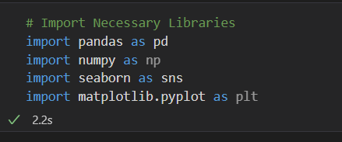

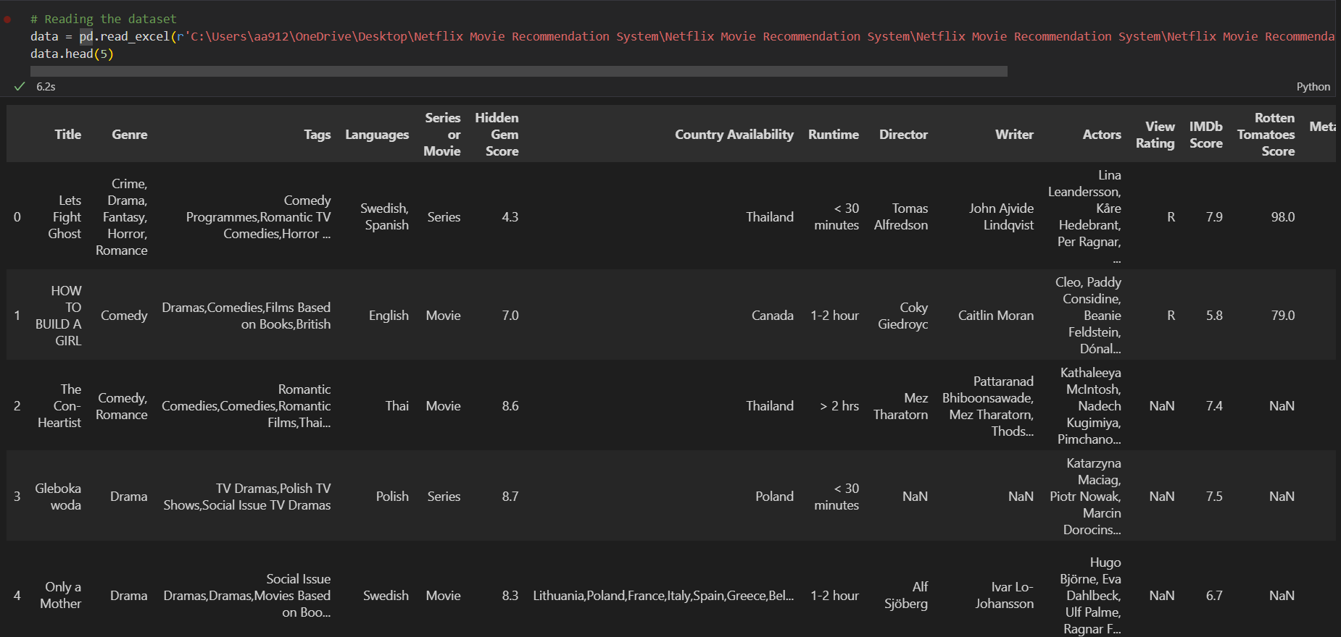

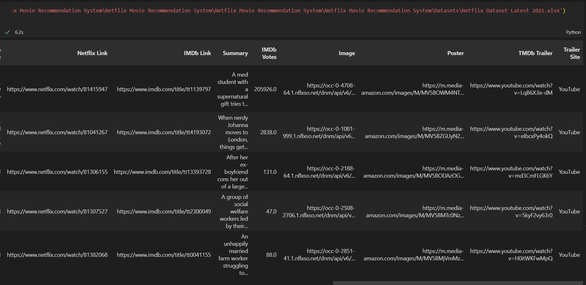

**Displaying All the Features Of the Dataset**

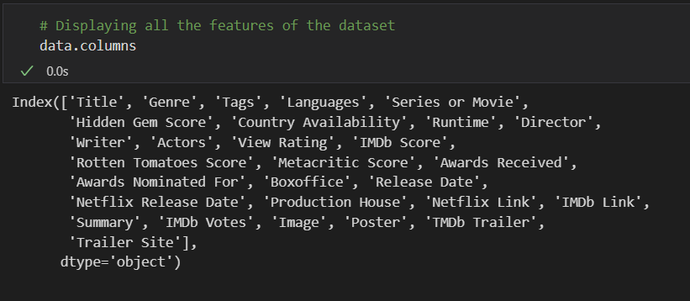

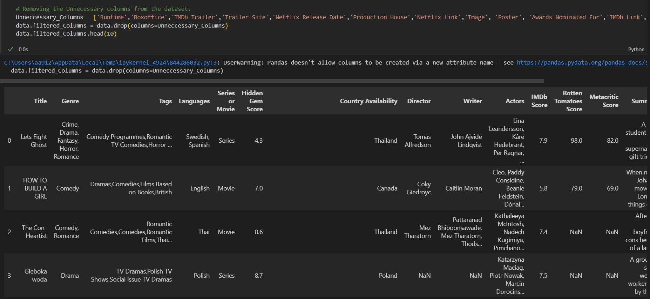

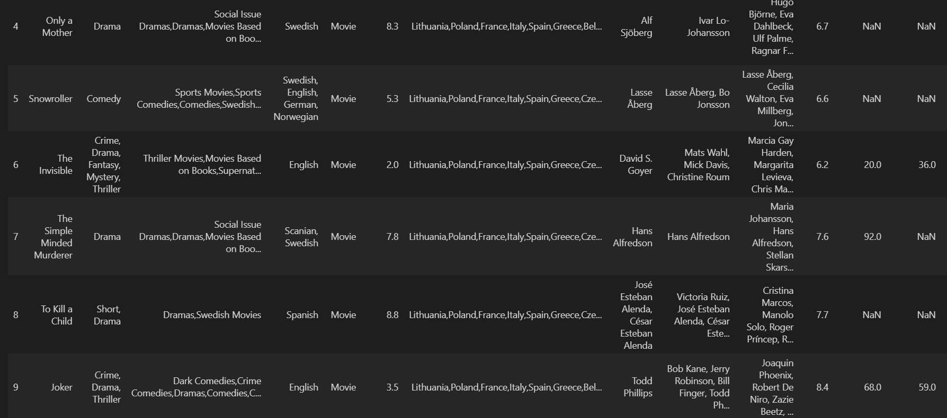

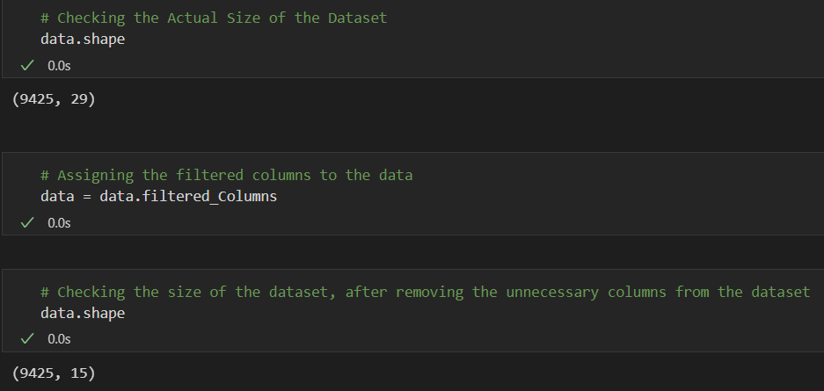

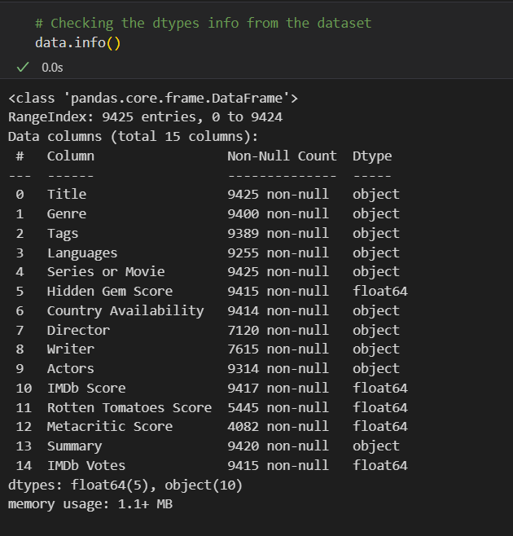

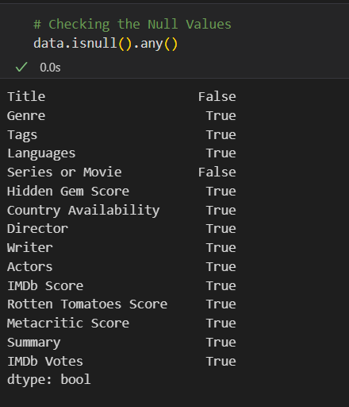

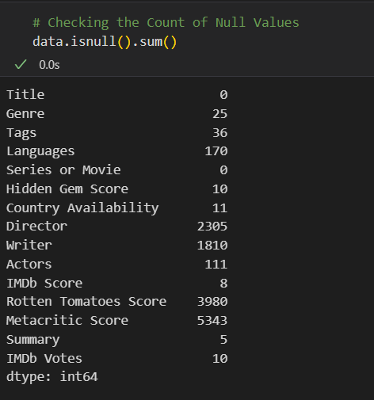

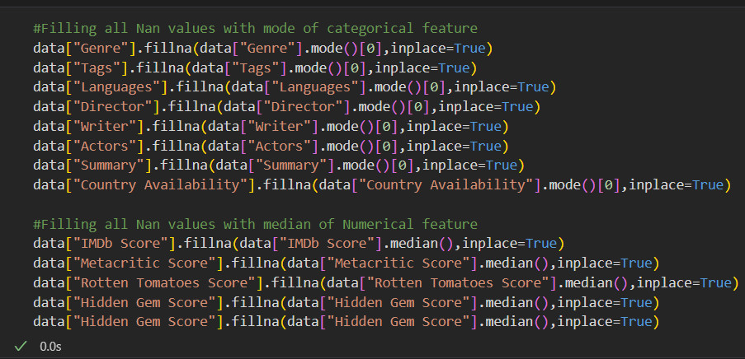

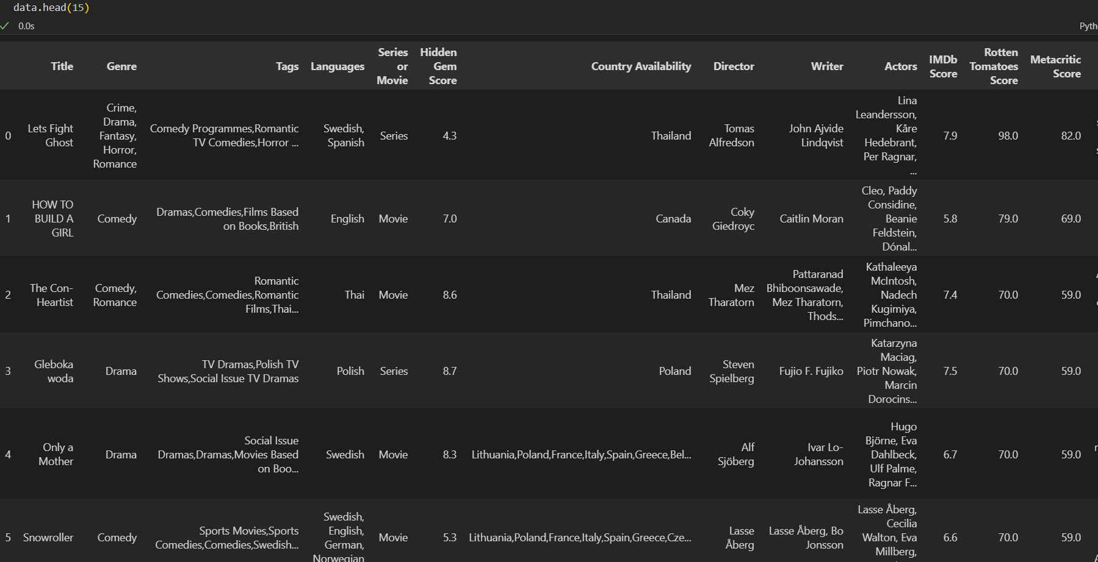

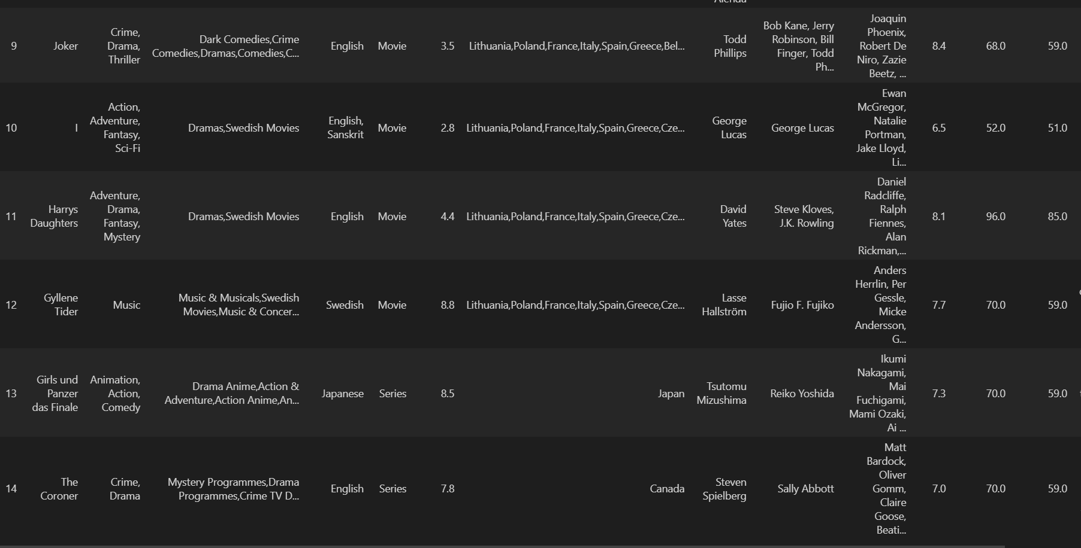

**Data Visualization:**

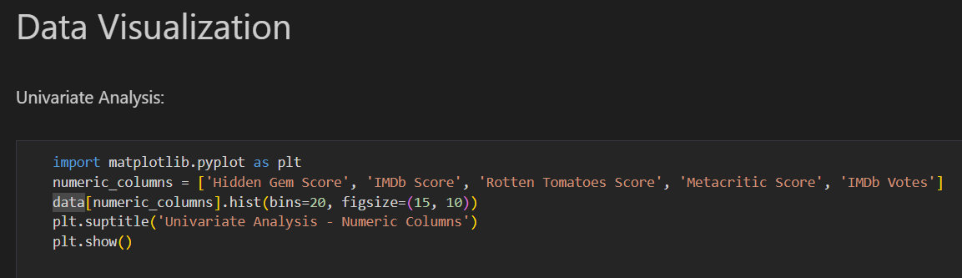

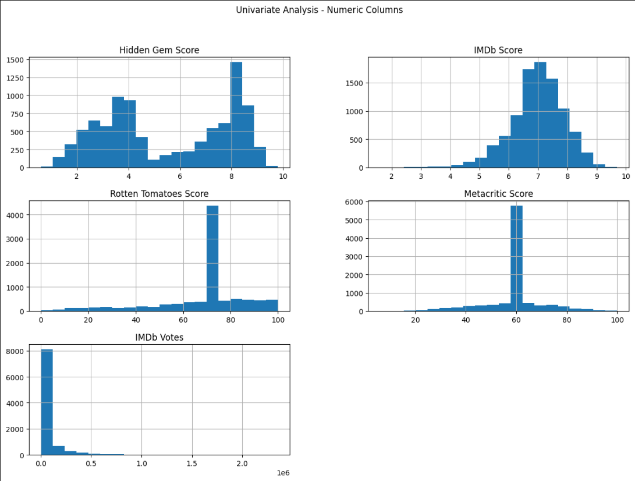

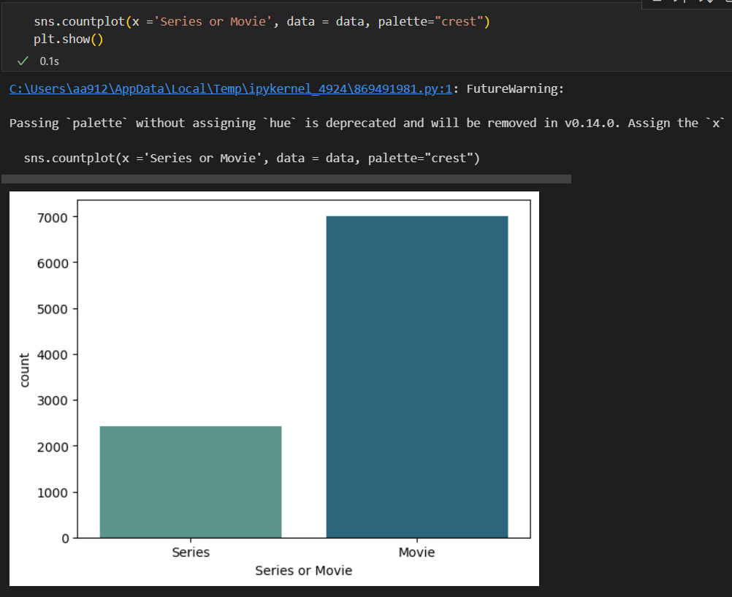

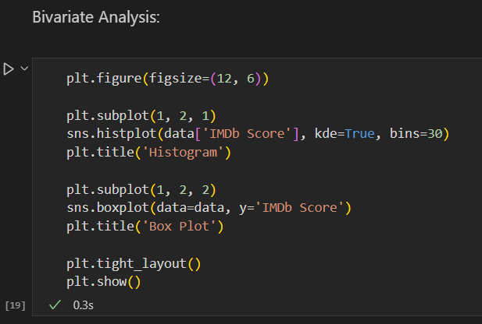

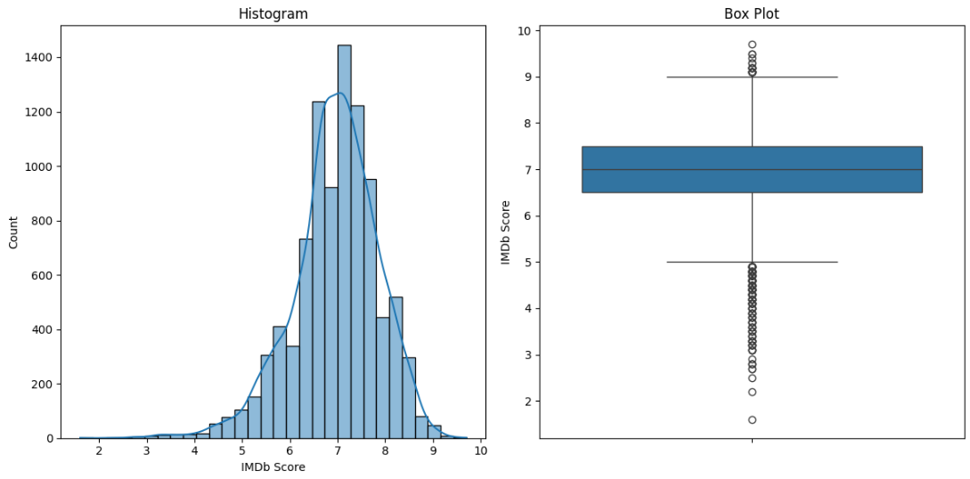

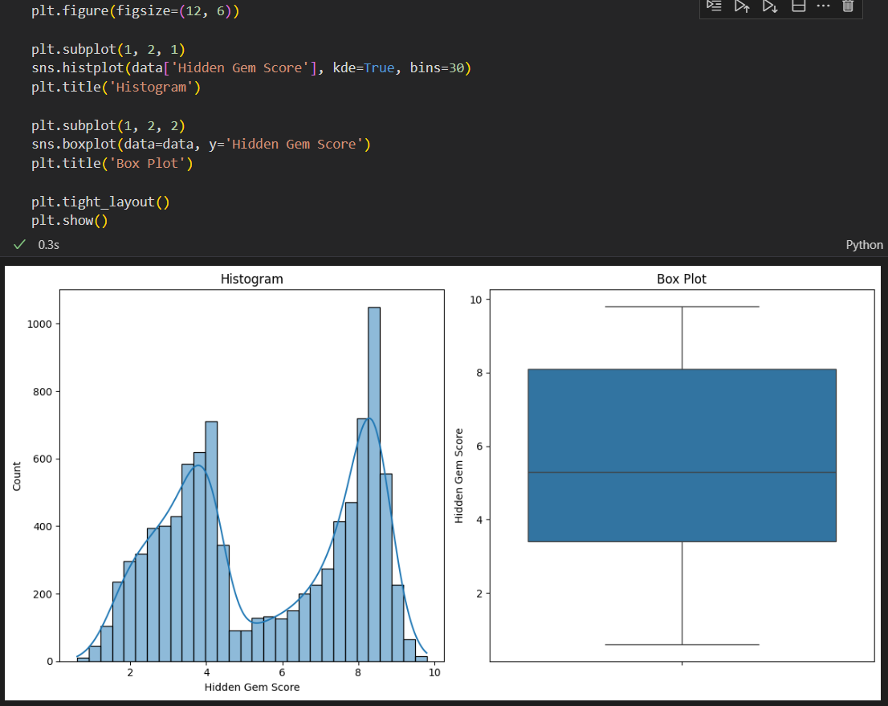

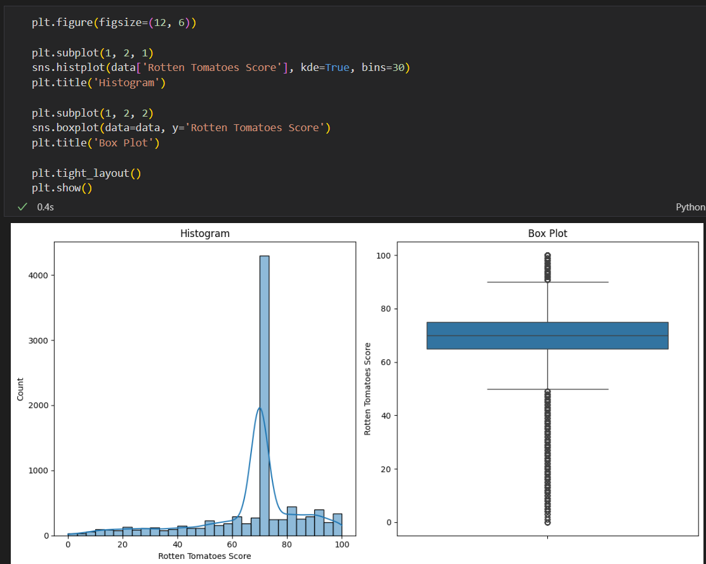

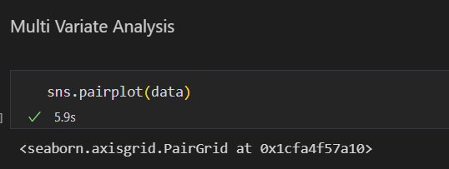

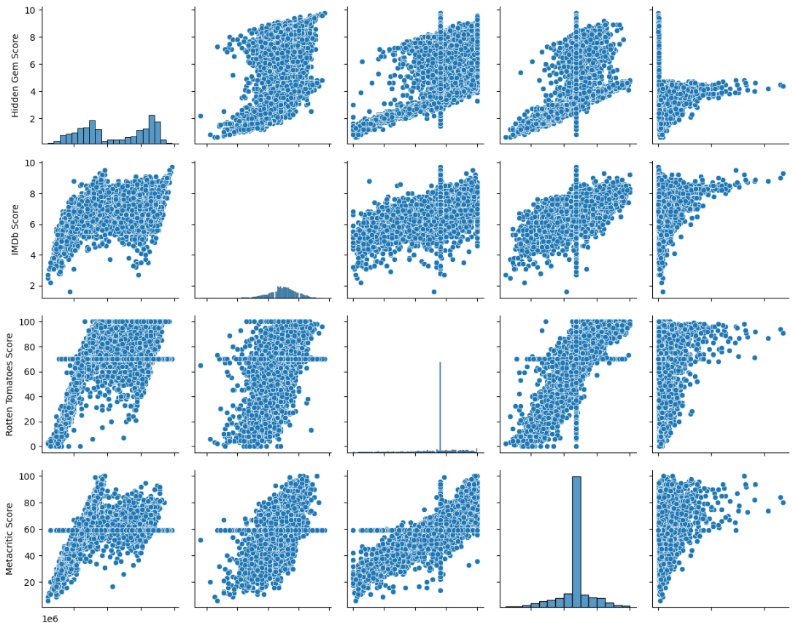

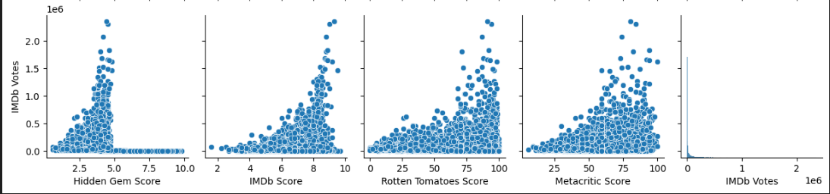

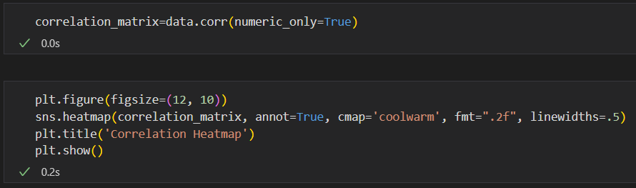

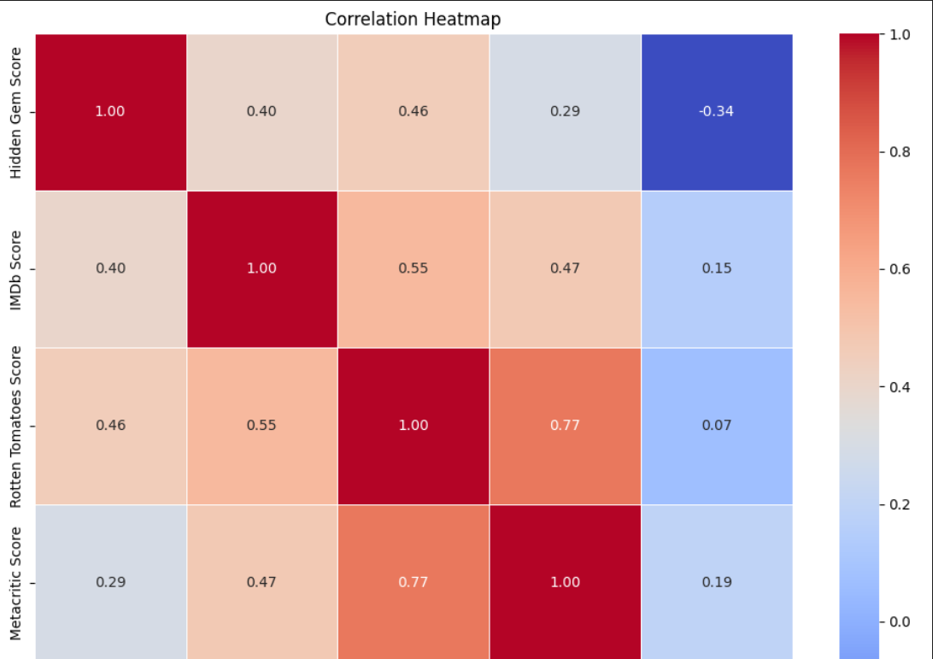

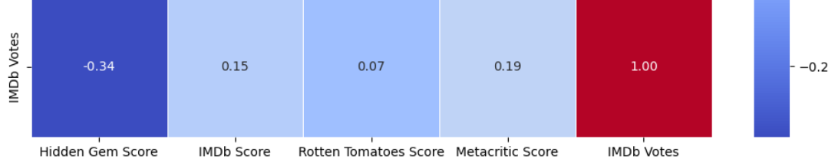

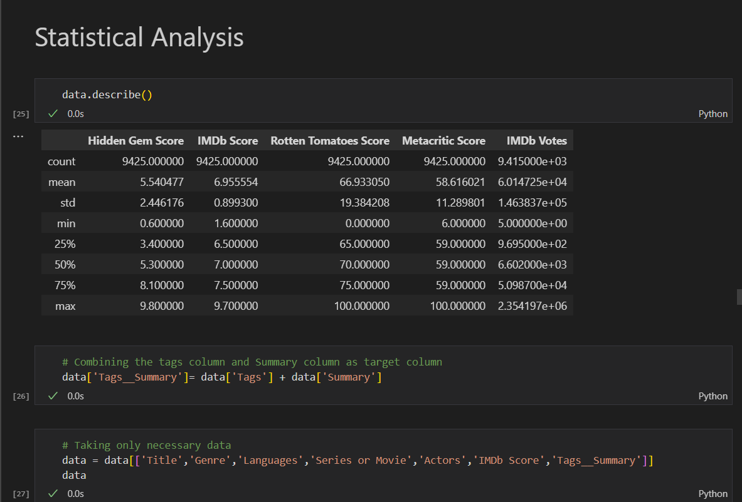

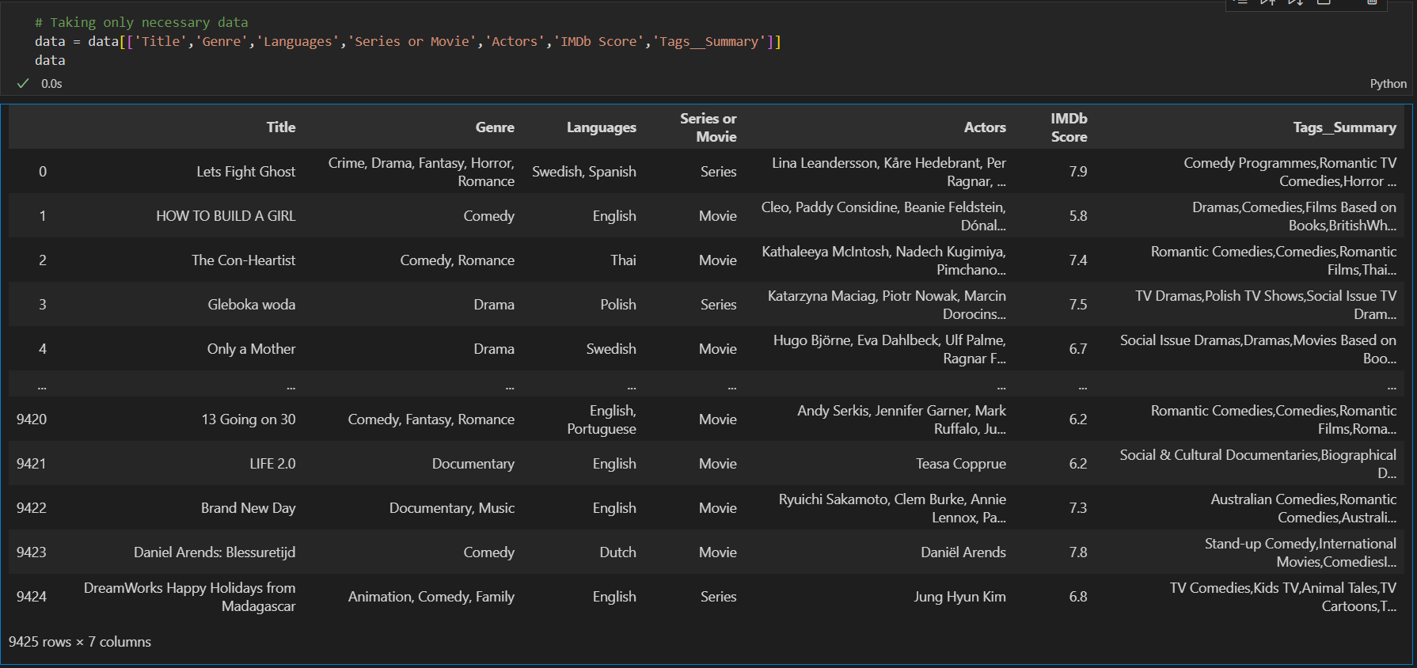

**Model Selection and Model Building**

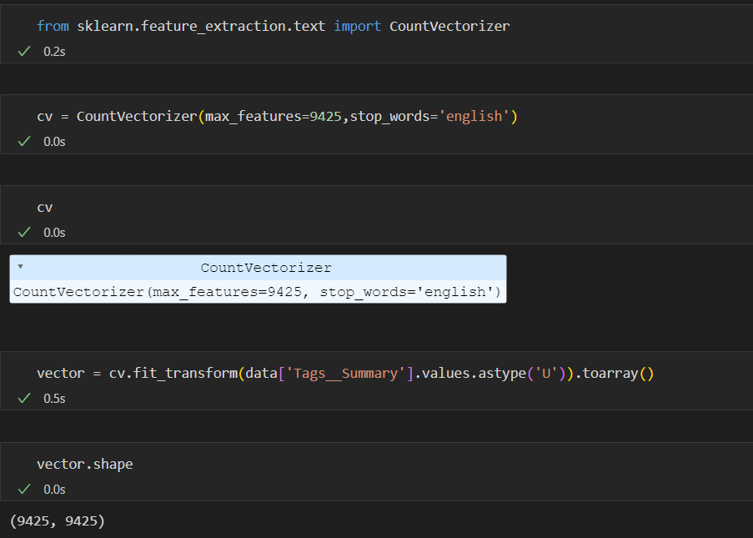

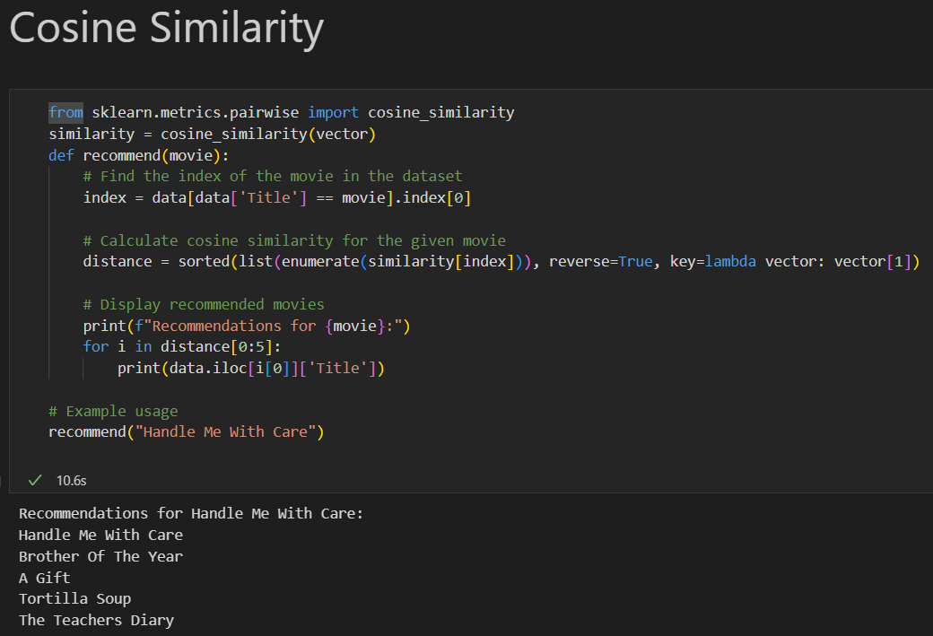

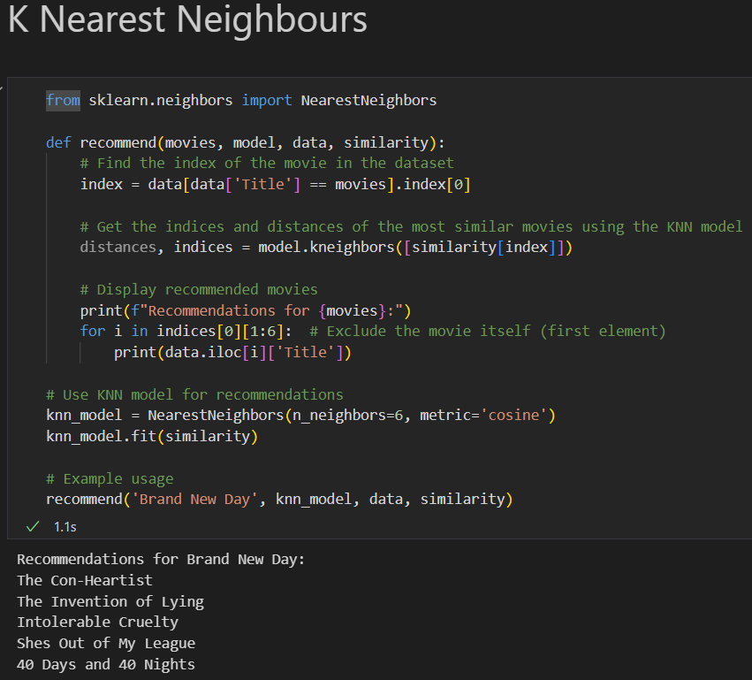

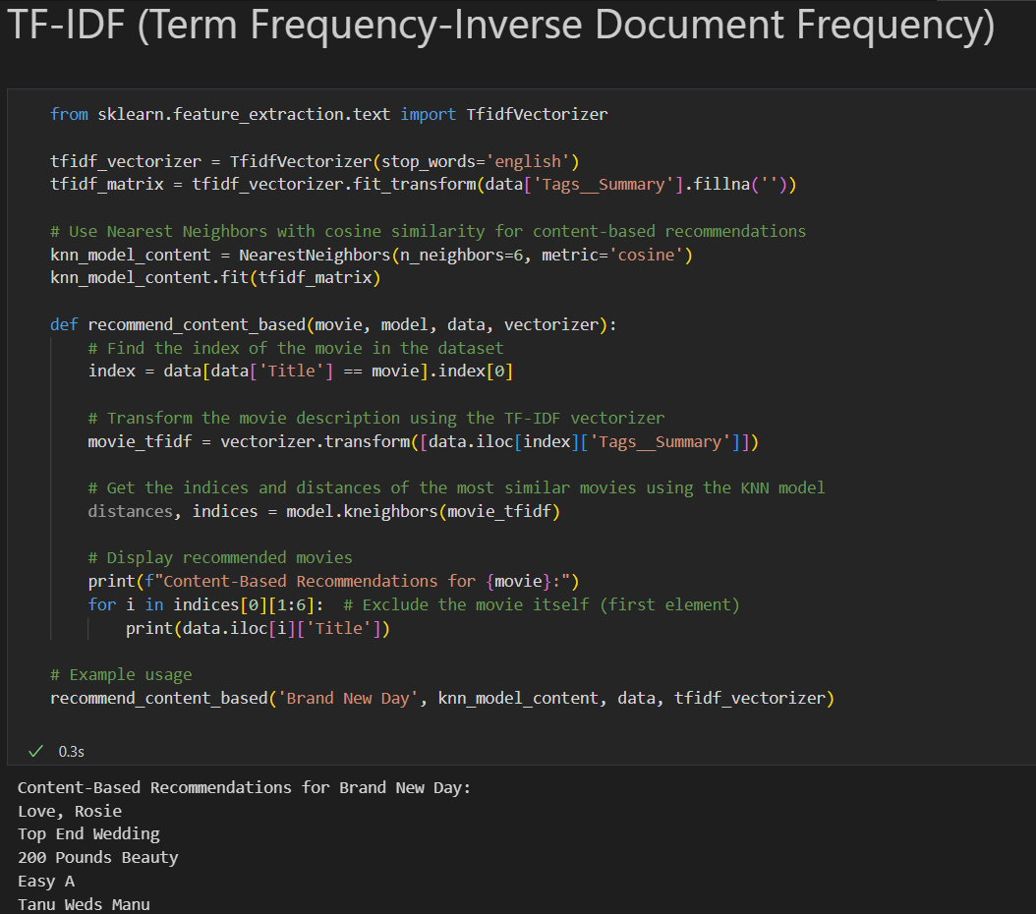

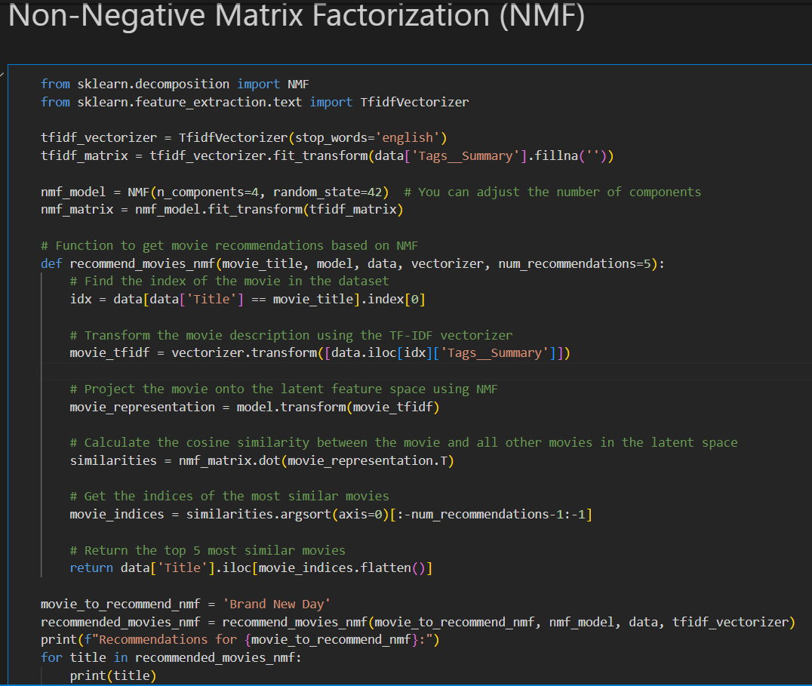

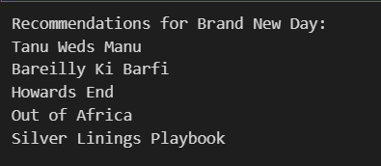

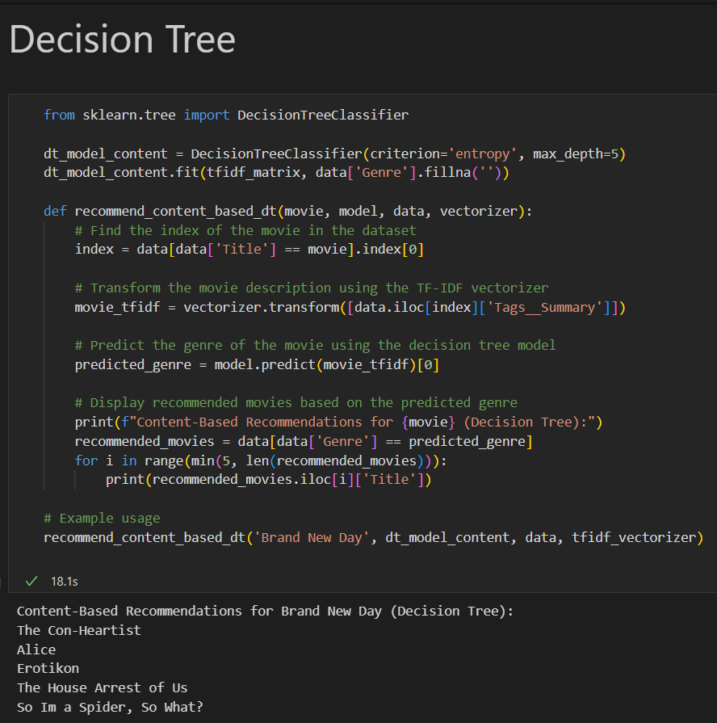

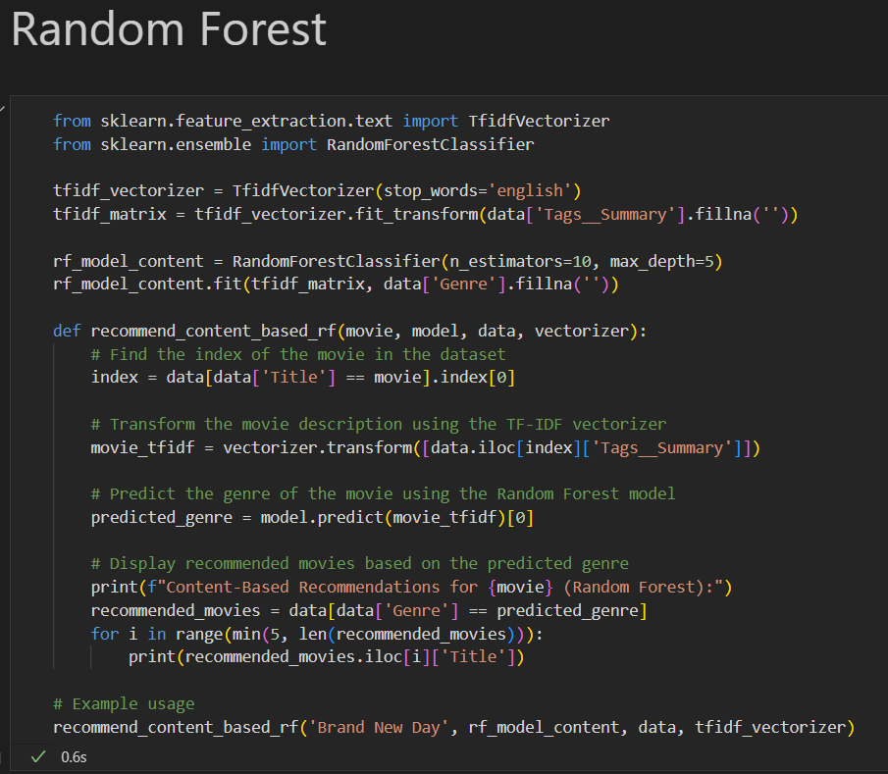

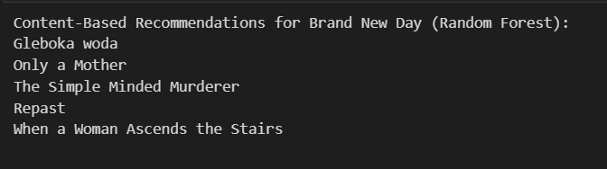

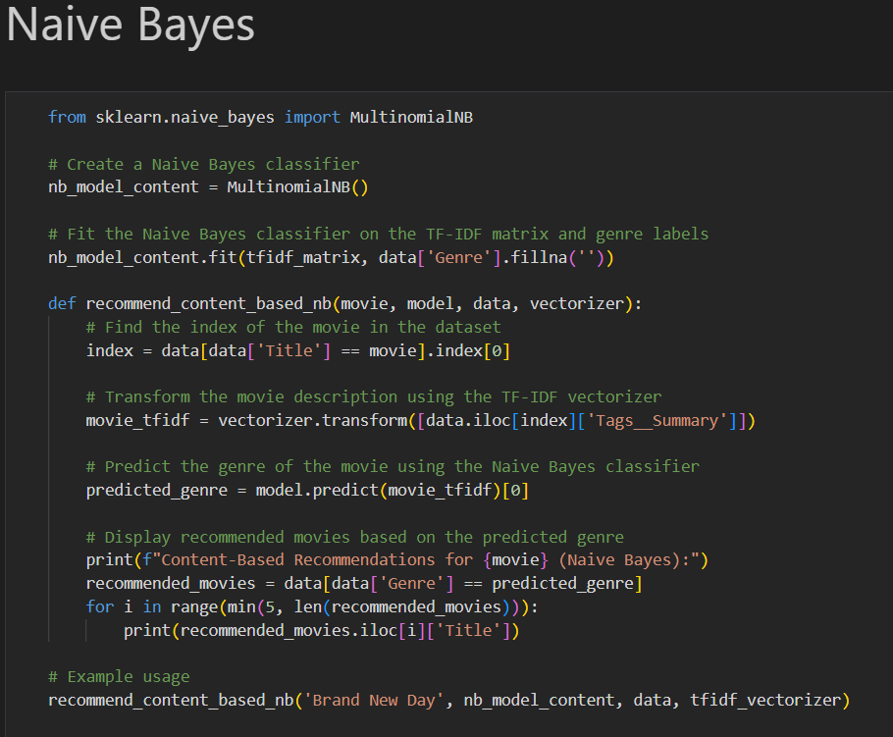

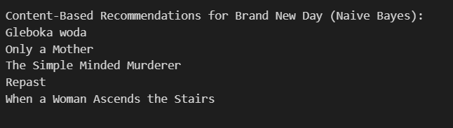

**Cross Validation**

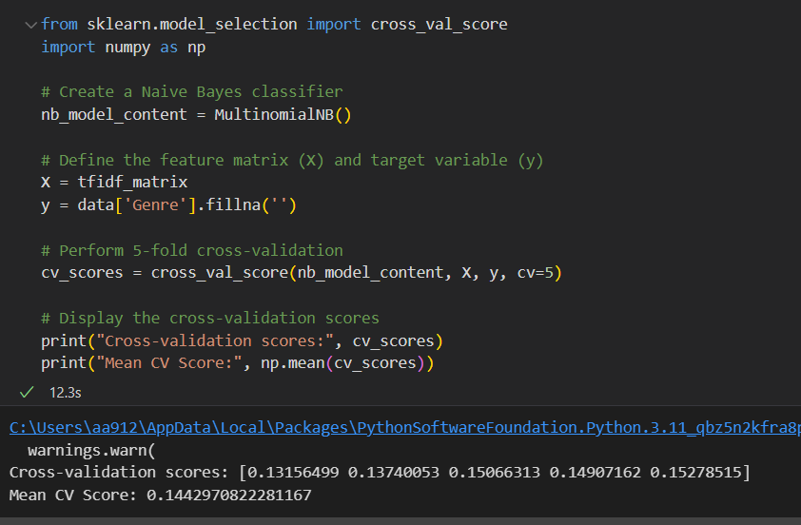

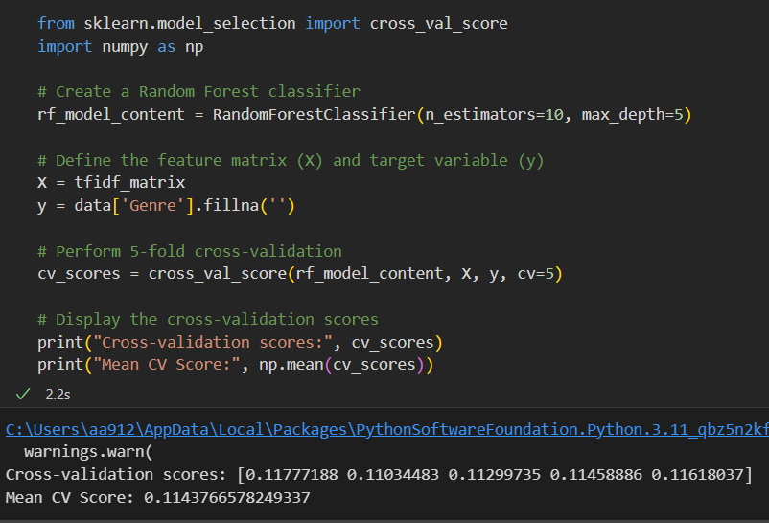

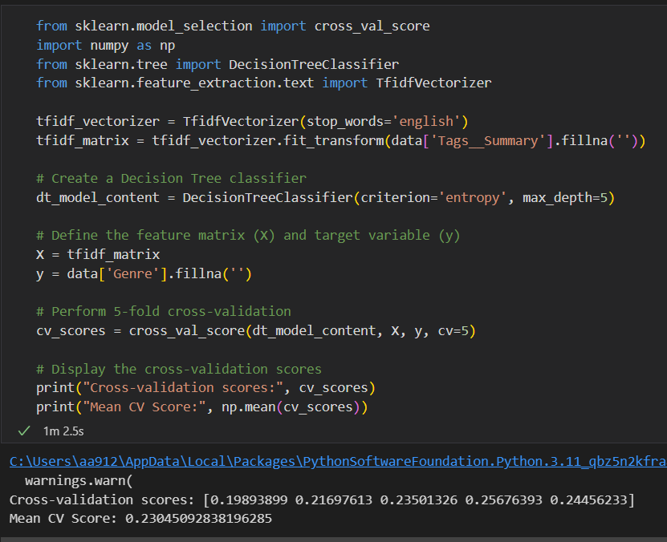

**HyperParameter Tuning**

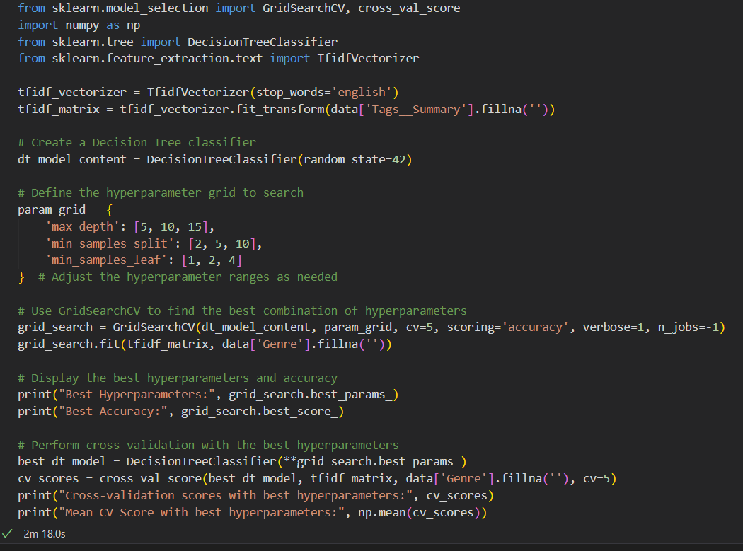

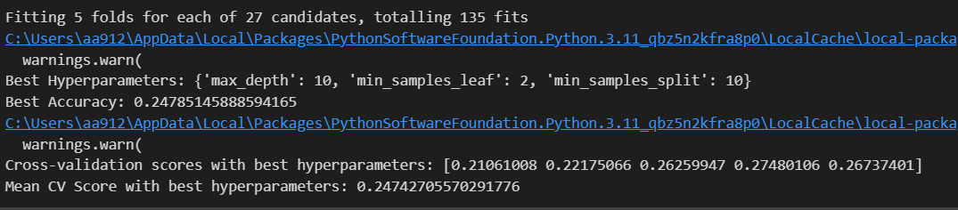

**Graph On Model Accuracy Comparison**

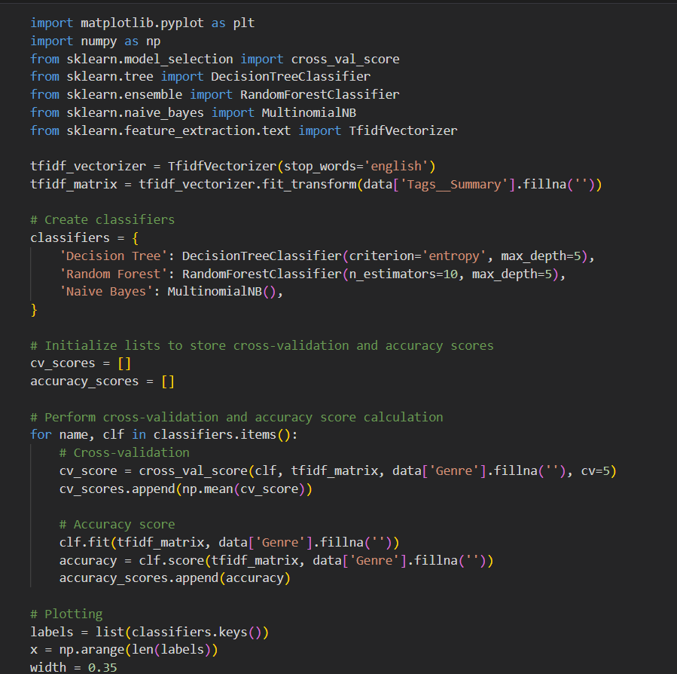

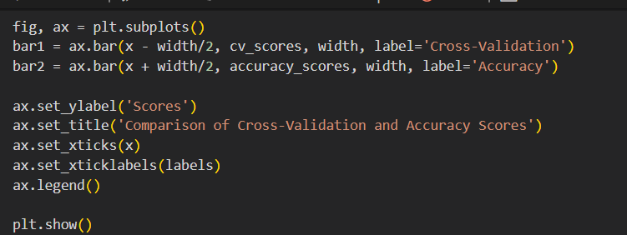

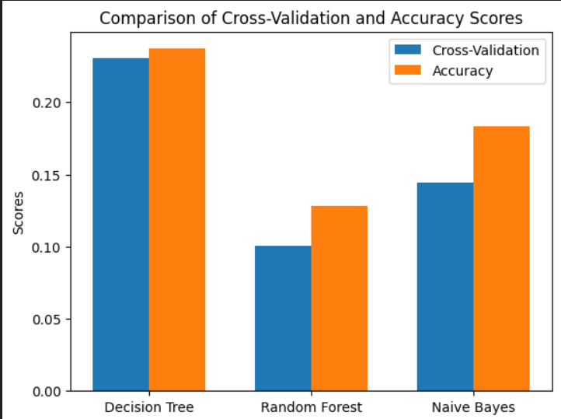

**Best Finalized Model**

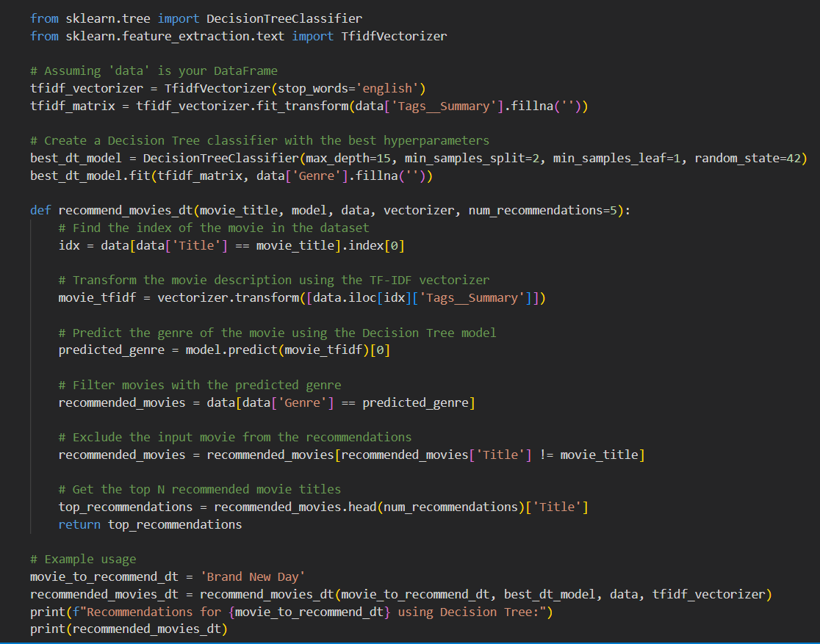

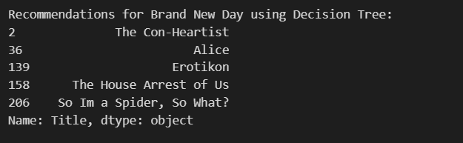

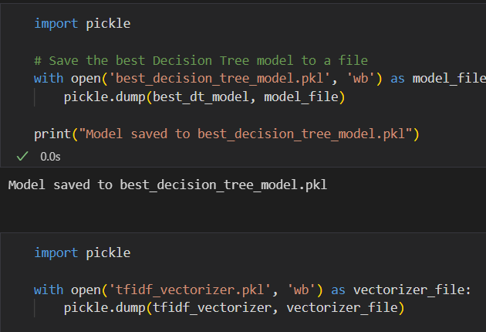

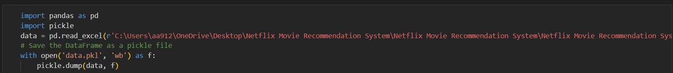

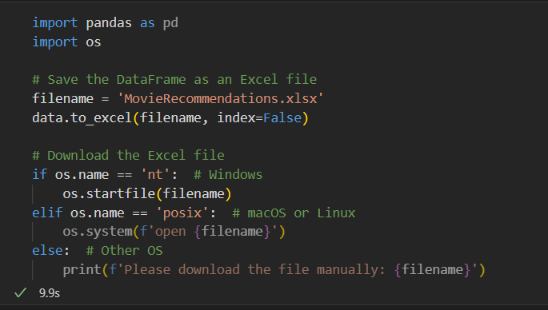

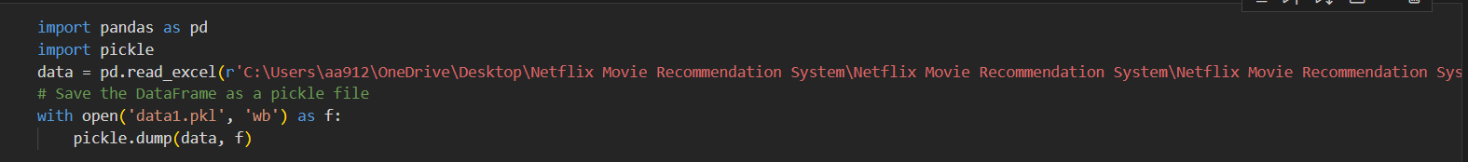

**Flask Integration**

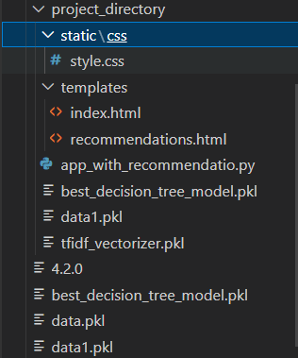

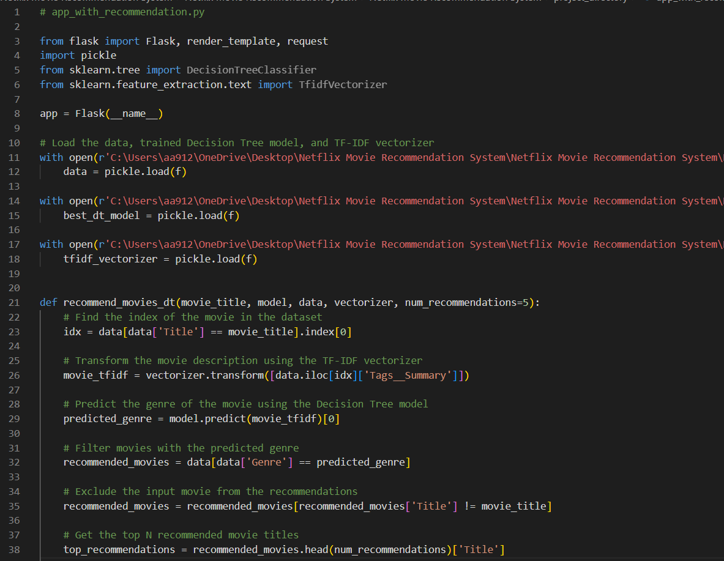

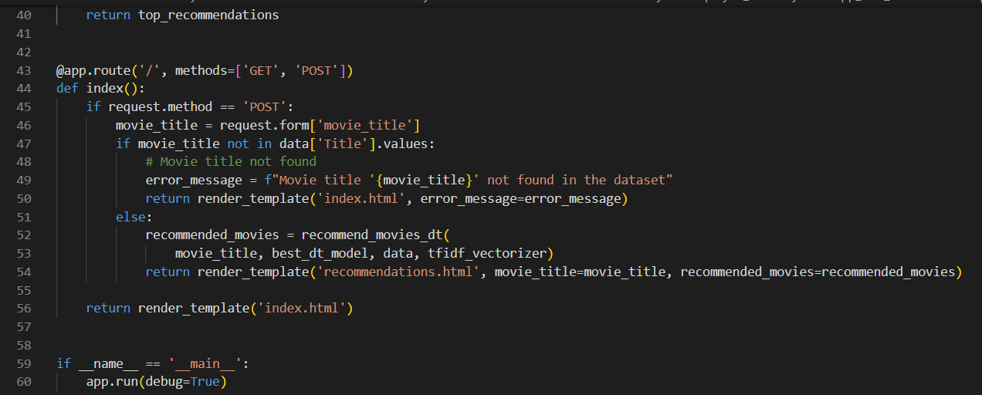

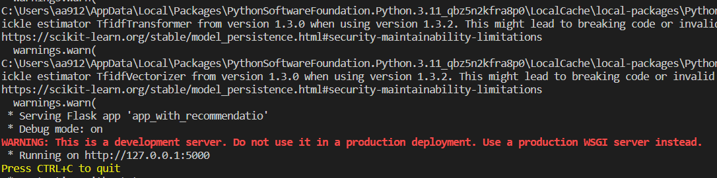

These are screenshots of the Netflix Movie Recommendation Engine, which is a machine learning project that recommends movies to users based on their viewing history. The background is black with a little bit of red and white in the center. The text "Netflix Movie Recommendation Engine" is written in white. There is a text field with the prompt "Enter Movie Title". Below the text field, there is a red button that reads "Find Recommendation". We can use the buttons to navigate through the engine and get recommendations to watch

**Home Page**

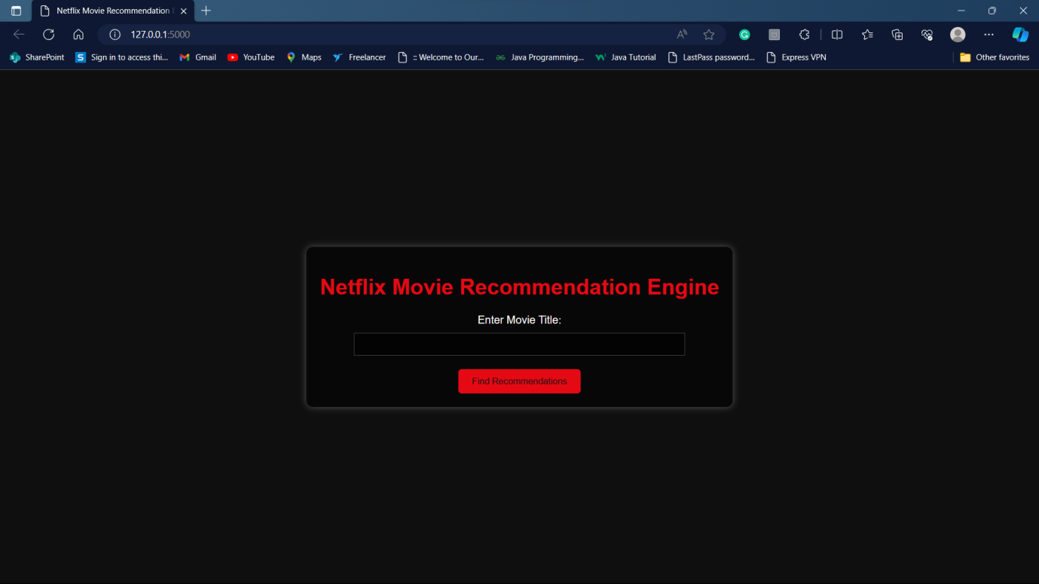

The Netflix recommendation system takes into account a lot of factors, such as:

1. Your interactions with the service (like viewing history and how you rated other titles).

2. Other members with similar tastes and preferences.

3. Information about the titles, such as their genre, categories, actors, release year, etc.

4. The time of day you watch.

5. The devices you are watching Netflix on.

6. How long you watch.

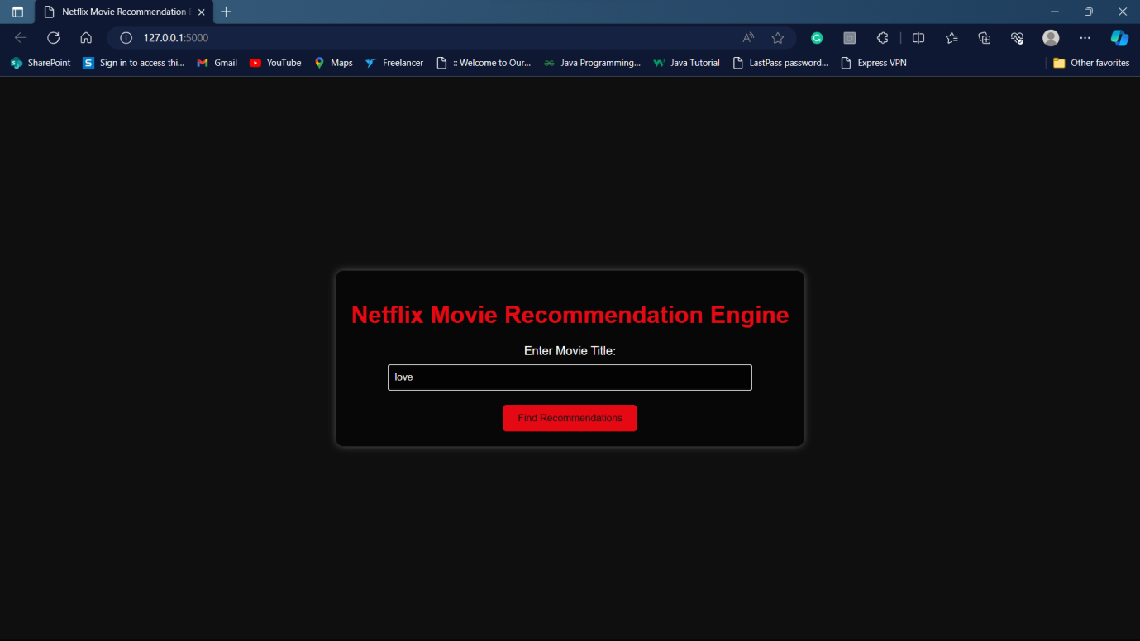

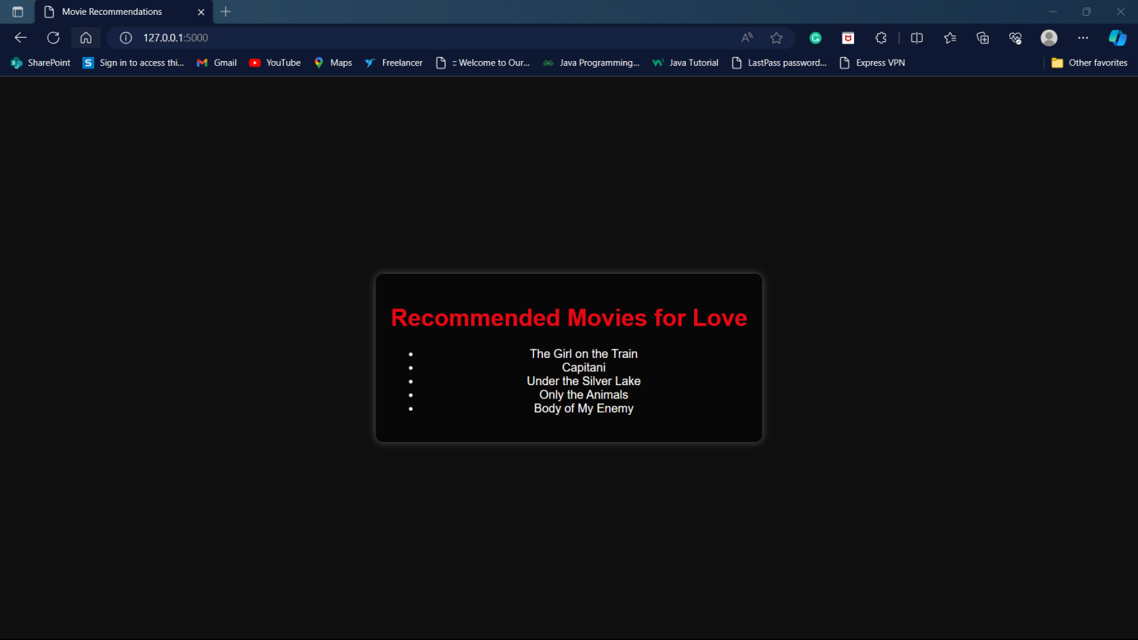

The system segments viewers into different taste groups and dictates recommendations based on the taste group a viewer falls into . With over 5000 TV shows and movies in the catalogue, it is actually impossible for a viewer to find movies they like to watch on their own. Netflix’s recommendation engine automates this search process for its users .

**Category As Iron Man**

